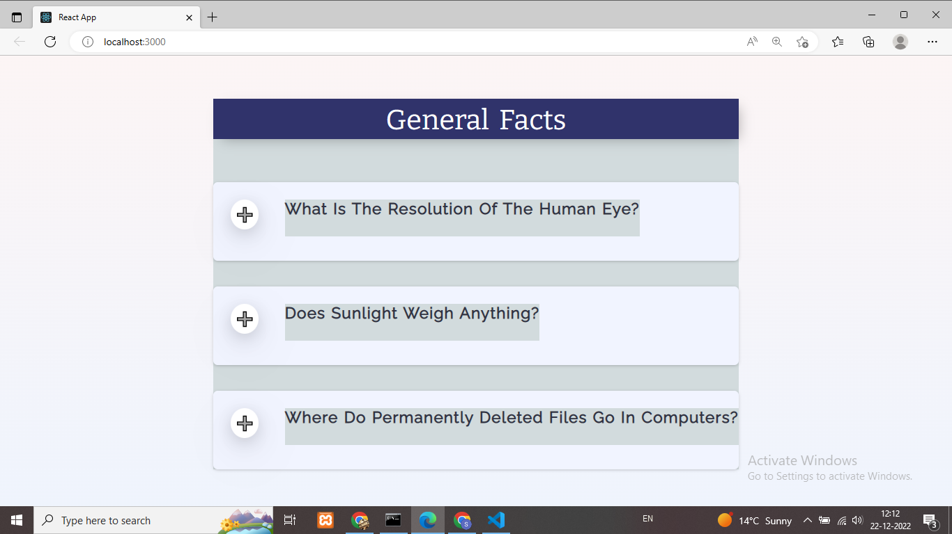

When we click on + icon

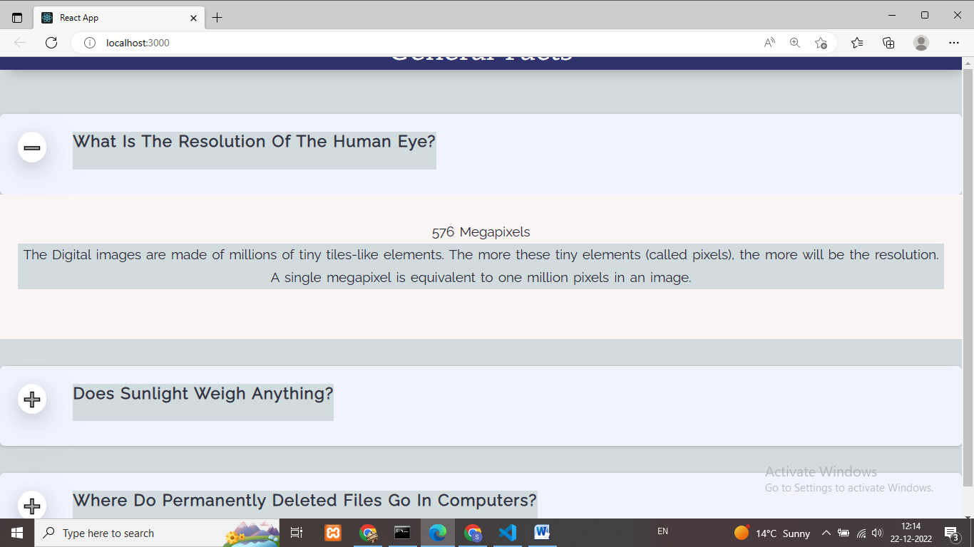

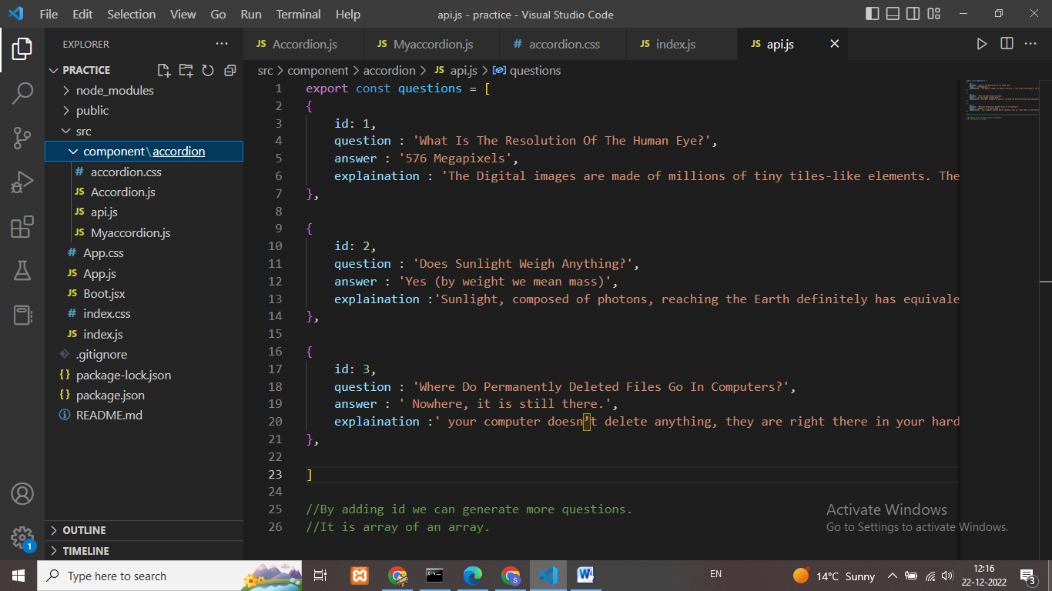

I have create a separate folder in src file:

Folder name : component

* Inner folder : accordion

Files

* Accordion.css
* Accordion.js
* Api.js
* Myaccordion.js